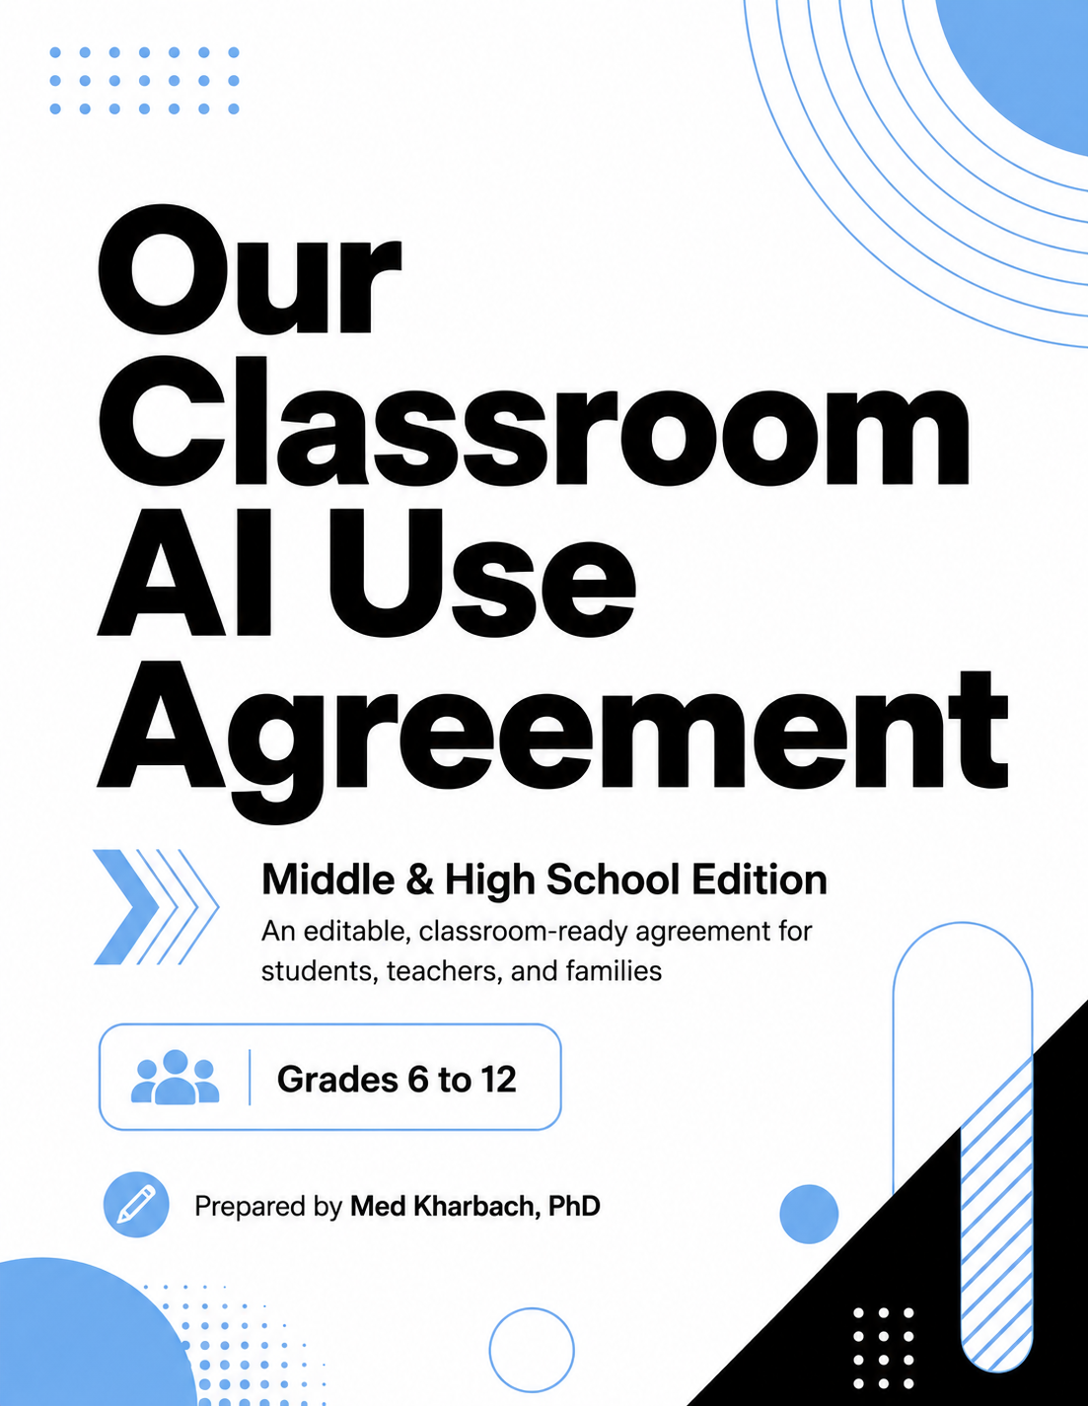

Introduction
One of the things I emphasize in my AI workshops, presentations, and broader research is the importance of pedagogy. I strongly believe that effective AI integration starts with a well-articulated pedagogy. As teachers and educators, we know better than anyone the centrality of pedagogy in shaping what actually happens in a classroom.
By AI pedagogy, I mean having a clear, well-defined, and intentional approach to how AI shows up in your teaching: what it's there to do, what it isn't, and what kind of thinking you want students doing alongside it. Transparency and clarity are important here. When students see why and how a tool is being used, they engage with it very differently from when they're just told to use it.
This is where the idea of class-level AI agreements comes in. These agreements are crucial because they create a shared understanding between teachers and students about what AI use looks like in this specific classroom: shared expectations, shared boundaries, and a shared sense of when AI is appropriate and when it isn't.
Students, and their parents, need to know how we as teachers will be using AI, in what capacity, and how their kids will be working with it on a daily basis. They also deserve to understand what kind of learning we're aiming for and the rationale behind our choices. All of this is part of the larger communication that should be happening between classrooms and families, especially in a moment as unstable as this one, where the conversation around AI in teaching and learning is too often overshadowed by fear, hype, and disagreement.
A clear outline does two things at once. It grounds your AI (and technology) integration in pedagogically sound practice, and it provides the reassurance that we, our students, and their parents all need right now. Both pieces tell everyone involved that the work has been thought through and that we're moving forward together.
AI use looks very different across grade levels and learning contexts. The expectations for using AI with entry-level elementary students are not the same as those for middle and high schoolers, and college students operate in a context that's different again. A second grader exploring AI on a classroom smartboard alongside their teacher is in a completely different situation from a graduate student using AI as part of a thesis project. The agreement that fits one will not fit the other.
I should also say that most of my AI work so far has focused on high school and higher ed teachers. It's only recently that I've started looking more seriously at the potential of AI in elementary classrooms, especially now that I'll be teaching a course on Curriculum and Technology Integration to future elementary teachers. That shift in audience is part of what pushed me toward this project.
This document is the middle and high school edition, designed for grades 6 to 12. Alongside it, I've put together two other editions: one for elementary teachers (K to 5), and one for higher education instructors. A combined master document gathers all three editions into a single file for anyone who wants the full set. Each version reflects the developmental realities of the students it's designed for and the kinds of decisions teachers actually face at that level.
At the middle and high school level, the conversation about AI shifts in important ways. Students at this age are using AI on their own, often outside of class, sometimes with personal accounts and sometimes without much guidance. The stakes also become real in ways they aren't at the elementary level. Grades, transcripts, GPA, and eventually college applications start to depend on the work students submit. This edition leans more heavily into student responsibility and disclosure as a routine practice, with a clearer line between using AI to support learning and using it to bypass learning. The disclosure form is built to be photocopied or pasted into Google Classroom so students get into the habit of explaining how AI showed up in their work.
A quick word on terminology. I prefer the word agreement to the word policy. Policy carries overtones of authority, hierarchy, and top-down rules, which aren't usually conducive to building the kind of friendly, student-centered classroom culture I'd want to see in any school. Agreement, by contrast, signals something collaborative. It says we built this together and we're going to follow it together. The word change is small, but it shapes how the whole document reads to a student or a parent.
A note on how this came together. After I shared an earlier version of these AI use templates, originally built in Canva and made available as a PDF, a number of teachers wrote in with constructive feedback. Many of them asked for editable versions they could adapt to their own teaching contexts, which made complete sense to me.
So I went back to the original templates, worked with Claude and ChatGPT to refine and expand the content, and turned everything into editable Word documents. I'm not making any money from this work. It's done in the spirit of sharing, and helping fellow teachers and educators put AI to use thoughtfully in their classrooms.
There are several AI literacy frameworks already out there (e.g., Chiu, 2025), and I've covered many of them on my academic blog and in my book Teaching with AI. Most of those frameworks are conceptually focused. They're useful for thinking about curriculum alignment and longer-term goals, but they're hard to translate into something a classroom teacher can actually pick up and use on a Tuesday morning. This short guide tries to fill that gap, in an informal way, since it isn't an academic work by any means.
I like the work of Perkins, Roe, and Furze on the AI Assessment Scale, and I'm aware of its limitations and the critique it has received over the past couple of years. I still think it offers practical insights for teachers, especially around setting expectations across different kinds of assignments. The traffic-light idea behind these templates is partly inspired by that work. For this middle and high school edition, I adapted it into a four-level scale (Levels 0 through 3) that fits the kinds of assignments common at this age. The full five-category version appears in the higher education edition, where its top level (AI-integrated work) genuinely fits the kinds of assignments instructors design at that level.
I hope you find these templates useful and adaptable for your own teaching context. If you have questions, feedback, suggestions, or are interested in having me facilitate a workshop for your school or faculty, please feel free to reach out at info@medkharbach.com.

Copyright © 2026 Med Kharbach, PhD

This work is licensed under a Creative Commons Attribution-NonCommercial-ShareAlike 4.0 International License. You are free to share (copy and redistribute the material in any medium or format) and adapt (remix, transform, and build upon the material) under the following conditions: appropriate credit must be given, a link to the license must be provided, and any changes must be indicated. The material may not be used for commercial purposes. If you remix, transform, or build upon the material, you must distribute your contributions under the same license as the original.
License details: creativecommons.org/licenses/by-nc-sa/4.0/

A Note for the Teacher
Purpose, AI use levels, and subject-specific guidance
This AI Use Agreement is designed to help middle and high school teachers set clear expectations for responsible AI use. It should be adapted to your subject area, grade level, school policy, and your students' needs. The goal is not to ban or promote AI blindly, but to help students use AI thoughtfully, ethically, and transparently. The document works as a syllabus appendix or as a separate signed agreement, depending on how your school handles paperwork.
Approved AI Tools in Our Class
List the AI tools approved for your classroom or district. Add or remove rows as needed. Students should not use unapproved tools for class assignments.
- ___________________________________________________________________
- ___________________________________________________________________
- ___________________________________________________________________
- ___________________________________________________________________

AI Use Levels Used in This Class
This is the full reference for the four-level scale used across assignments. Each assignment will be set at one of these levels by the teacher.
Level | What It Means | Example
Level 0  No AI | You complete the task without any AI help. The work shows your own knowledge, thinking, and skills. | In-class essays, tests, quizzes, oral exams, problem sets meant for skill-building.
Level 1  AI for planning | You may use AI for brainstorming, outlining, vocabulary support, or study planning. Your final work is your own writing and thinking. | Generating topic ideas, outlining a research paper, building a study schedule.
Level 2  AI for feedback | You may use AI to get feedback on your ideas, structure, grammar, or clarity, but you revise the work yourself. | Asking AI to flag unclear paragraphs, point out weak arguments, or check grammar after you draft.
Level 3  AI-assisted creation | You may use AI to help generate, transform, or develop parts of the work. You must disclose what you used, evaluate the output, and show your own contribution. | Using AI to draft alternative introductions, generate code suggestions you debug, or create visuals you refine.

Subject-Specific Examples (Editable)
These are starting points only. Adapt the typical levels and examples to fit your specific assignments and goals.
Subject Area | Typical Level | Notes / Examples
English / Language Arts | Level 1 to 2 | Brainstorming and feedback allowed; final writing is your own.
Mathematics | Level 0 to 1 | Concept review and study planning; problem sets done without AI.
Science / Lab | Level 1 to 2 | Outline lab reports with AI; results, analysis, and conclusions are yours.
History / Social Studies | Level 1 to 2 | Source brainstorming and feedback; AI-generated facts must be verified.
World Languages | Level 0 to 1 | Vocabulary and study support; written assignments without translation tools.
Computer Science | Level 1 to 3 | Code suggestions and debugging help with full disclosure of AI use.
Visual / Performing Arts | Varies by piece | Specified per assignment; concept development sometimes Level 2 or 3.

AI tools change quickly. Plan to revisit this agreement at least once a semester and update the approved tools list when new platforms are introduced or removed.
Student AI Use Agreement
How AI may and may not be used in this class
Why We Use AI in This Class
In this class, AI may be used to support and enhance learning. AI can help with brainstorming, organizing ideas, practicing concepts, generating study questions, revising drafts, exploring examples, and receiving feedback. You remain responsible for your own thinking, decisions, and final work.
Approved Tools Only
You may only use the AI tools your teacher and school have approved. Do not use other AI tools for class assignments, especially tools that collect personal data or require accounts the school has not approved.
AI Use Levels
Every assignment in this class will be set at one of four levels. Pay attention to the level before you start working.
Level | What It Means | Example
Level 0  No AI | You complete the task without any AI help. The work shows your own knowledge, thinking, and skills. | In-class essays, tests, quizzes, oral exams, problem sets meant for skill-building.
Level 1  AI for planning | You may use AI for brainstorming, outlining, vocabulary support, or study planning. Your final work is your own writing and thinking. | Generating topic ideas, outlining a research paper, building a study schedule.
Level 2  AI for feedback | You may use AI to get feedback on your ideas, structure, grammar, or clarity, but you revise the work yourself. | Asking AI to flag unclear paragraphs, point out weak arguments, or check grammar after you draft.
Level 3  AI-assisted creation | You may use AI to help generate, transform, or develop parts of the work. You must disclose what you used, evaluate the output, and show your own contribution. | Using AI to draft alternative introductions, generate code suggestions you debug, or create visuals you refine.
What Is Acceptable AI Use
- brainstorming topic ideas
- asking for explanations of difficult concepts
- creating practice quiz questions
- asking for feedback on clarity
- checking grammar after writing a draft
- creating study plans
- comparing examples
- using AI for vocabulary or translation support when allowed by your teacher
- generating images or visuals when the teacher permits it

What Is Not Acceptable
- submitting AI-written work as your own
- copying AI answers without understanding them
- using AI during tests or quizzes unless allowed
- creating fake citations, fake sources, or fake data
- using AI to avoid reading assigned materials
- typing private information about yourself, classmates, teachers, or the school into AI tools
- using AI to bully, impersonate, cheat, or mislead others

How to Disclose AI Use
When AI helps you with an assignment, you must explain how. Use the AI Use Disclosure Form on the next page, or your teacher's preferred format. At minimum, describe:
- the tool you used
- what you asked it to do
- which parts of the work it helped with
- what you changed, rejected, or checked
- how you made the final work your own

Privacy and Safety
Do not type the following into any AI tool unless your school explicitly allows it:
- full names, including your own
- addresses or phone numbers
- passwords or school ID numbers
- private family information
- medical information
- photos or videos of classmates
- confidential school information
- another person's writing without their permission

Use school-approved or school-managed AI tools for schoolwork when available. Public AI tools may store or learn from what you type.
Accuracy and Verification
AI can sound confident and still be wrong. It may invent facts, sources, quotations, or citations. You must verify important information using class materials, teacher-approved sources, library databases, books, or reliable websites. Before using AI information in your work, run through this check:
☐ Can I verify this from another source?
☐ Does it match what we learned in class?
☐ Is there a real, locatable source?
☐ Does the answer make sense?
☐ Did I understand it well enough to explain it myself?

Academic Integrity
Using AI without permission or disclosure may count as academic misconduct. The seriousness depends on the assignment, the amount of AI use, and your honesty about the process. When mistakes happen, the first step is usually a conversation, reflection, and revision. Repeated or intentional misuse may follow school academic integrity procedures.
Equity and Access
You will not be penalized for lacking access to paid AI tools or devices at home. When AI use is part of an assignment, your teacher will provide access, alternatives, or non-AI options.
Responsible Communication and Digital Citizenship
You may not use AI to create harmful, misleading, offensive, or impersonated content. This includes fake messages, fake images, deepfakes, harassment, or content that targets classmates, teachers, or community members. AI misuse that harms others falls under both this agreement and your school's conduct code.
Review and Revisit
This agreement may be revised during the year as new tools appear, school policies change, or class needs shift. Your teacher will let you know when changes happen.
Student Responsibility Statement
I understand that AI can support my learning, but it cannot replace my thinking. I agree to use AI honestly, safely, and responsibly. I will ask when I am unsure, disclose AI help when required, protect private information, check AI outputs, and make sure my final work reflects my own understanding.

Student Name: _______________________________________ Signature: _______________________ Date: ____________
Teacher: ________________________________________ Class: ______________________________
AI Use Disclosure Form
Attach this form to any assignment where you used AI
Student Name: ____________________________ Date: _____________
Class / Subject: ________________________ Assignment: ____________________
This assignment was set at Level (circle one): 0 1 2 3

1. AI tool I used:
_____________________________________________________________________
2. What I asked it to do (prompt or question):
_____________________________________________________________________
_____________________________________________________________________
_____________________________________________________________________
3. Which parts of the work AI helped with:
_____________________________________________________________________
_____________________________________________________________________
4. What I changed, rejected, or verified:
_____________________________________________________________________
_____________________________________________________________________
_____________________________________________________________________
5. How I made the final work my own:
_____________________________________________________________________
_____________________________________________________________________
_____________________________________________________________________

By signing below, I confirm that the disclosure above is accurate and that the final work reflects my own understanding.
Student Signature: _____________________________ Date: ____________
AI Use Quick Guide
A one-page reference for students. Print and keep it in your binder.
ALLOWED with teacher permission
- brainstorming and outlining
- getting feedback on drafts
- explaining tough concepts in simpler terms
- practice questions and study planning
- grammar checks after you draft

NOT ALLOWED
- submitting AI work as your own
- using AI on tests or quizzes unless told otherwise
- fake citations, fake quotes, fake data
- typing private information into AI tools
- using AI to harm, harass, or impersonate

ASK FIRST
If you are not sure whether AI is allowed for an assignment, ask your teacher before you use it. Always check the assignment's AI level before starting.

DISCLOSE
When AI helps you, fill out the AI Use Disclosure Form. Tool, prompt, what you kept, what you changed, how you verified.

VERIFY
AI can be wrong. Check facts, sources, and citations against class materials and reliable references before submitting.
A Note for Families (Optional)
An editable letter you may adapt and send home

Dear Families,
This year, our class is using a shared AI Use Agreement that explains how artificial intelligence (AI) tools may be used in our learning. I want to share what this looks like so you understand the framework your student is working within.
In our class AI is treated as a learning support. Each assignment is assigned an AI use level from 0 to 3, telling students how much AI use is allowed. When AI is used, students must disclose it using a short form that asks what tool they used, what they asked, what they kept, and how they verified the information.

In our classroom, students will:
- use only AI tools approved by our school
- avoid typing personal or private information into AI tools
- disclose AI use on assignments where it is allowed
- verify information from AI before submitting work

Students will not be penalized for lacking access to paid AI tools at home. When AI use is part of an assignment, alternatives or in-class access will be provided.
If you have questions about how AI fits into our class, please reach out. I will revisit and update the agreement as needed throughout the year.
Sincerely,
________________________________________
[Teacher Name]
[School / Grade Level / Subject]
[Contact Email]
About the Author
Med Kharbach, PhD, is an educator, researcher, and the editor of Educators Technology (educatorstechnology.com). A former K-12 teacher with nearly two decades of teaching experience across different K-12 settings. Med currently serves as an instructor at Mount Saint Vincent University, where he earned both his master’s degree and PhD. He is the author of Teaching with AI: Practical Strategies to Integrate AI in The Classroom, and co-author of The AI Turn in Academic Research and The BEARA Framework for Pedagogical Integration with Dr. Jonathan Woodworth. His work focuses on AI literacy, assessment in the age of AI, and practical classroom applications of educational technology. You can read more about Med and his research at medkharbach.com.

